1. Ensure Your region is set to “N Virginia”
2. Create 1 EC2 Instance using the 7 step workflow
3. Use the usual Amazon Linux AMI in AZ1
4. Download a new PEM file and ssh to the instance

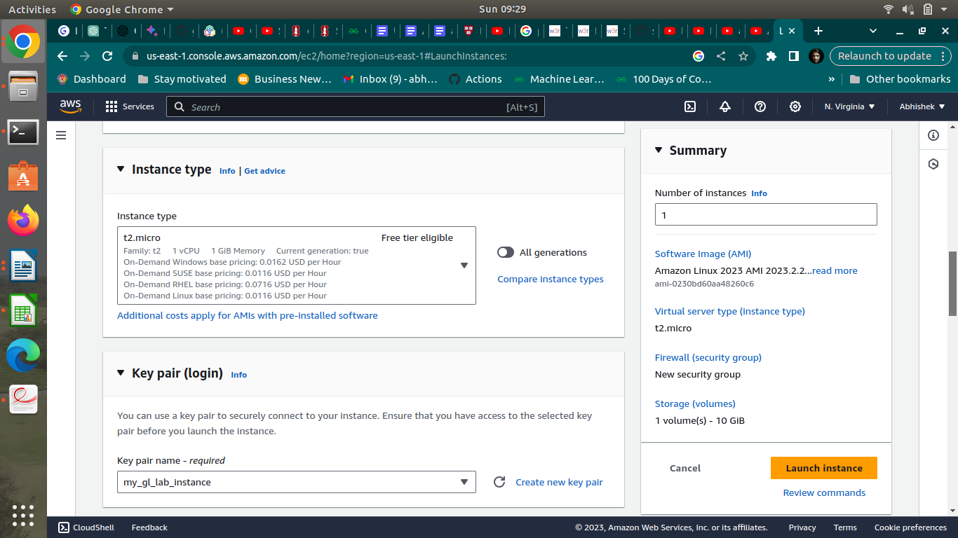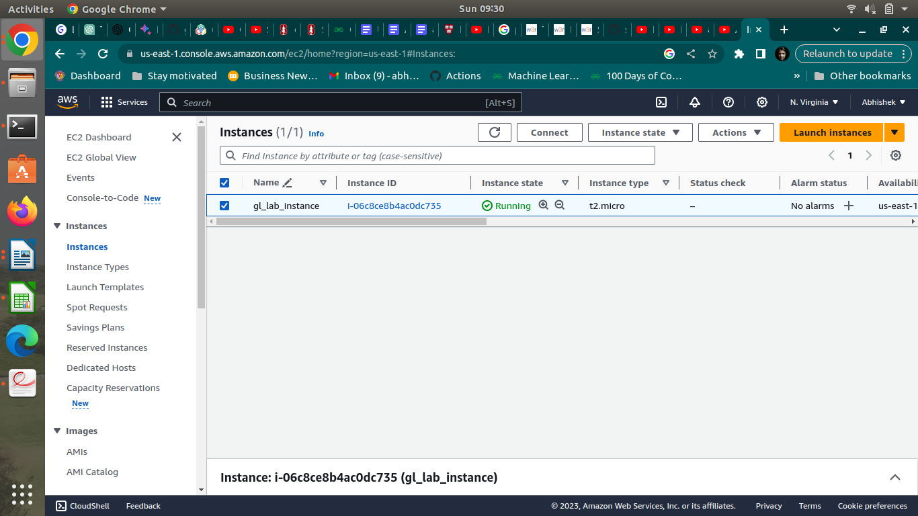

3. Volumes

1. Use the console to get a 10G magnetic volume in the same AZ1
2. Attach the volume to the instance
3. Format the volume and mount it
4. Create a sample text file in the volume to simulate data creation
5. Unmount, detach the volume

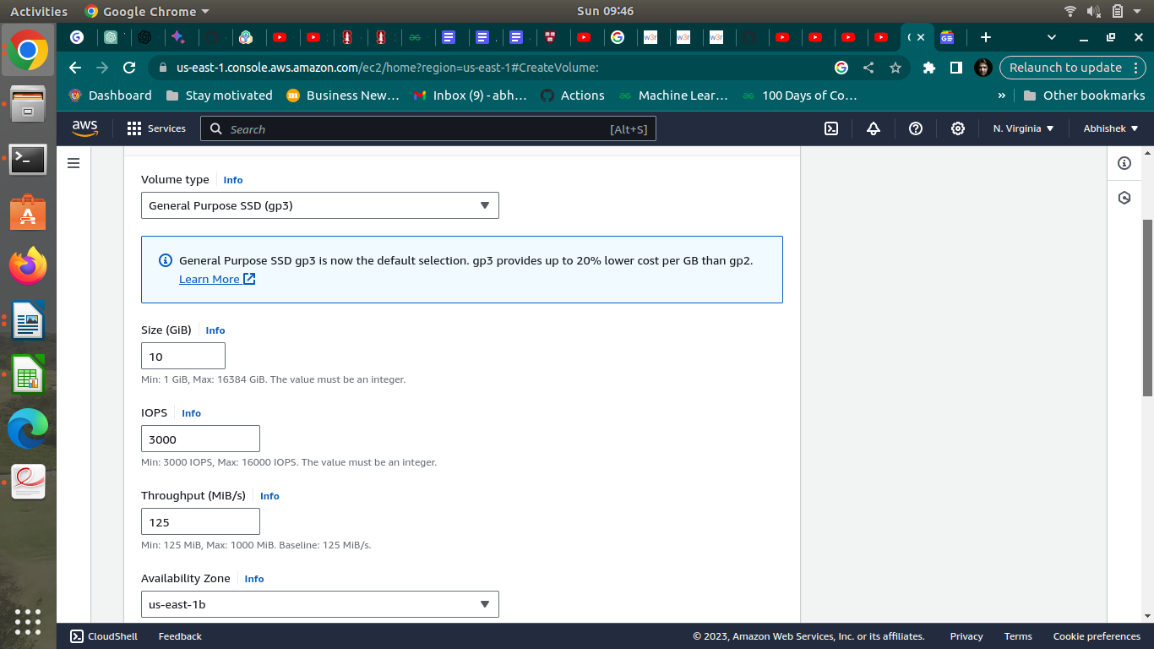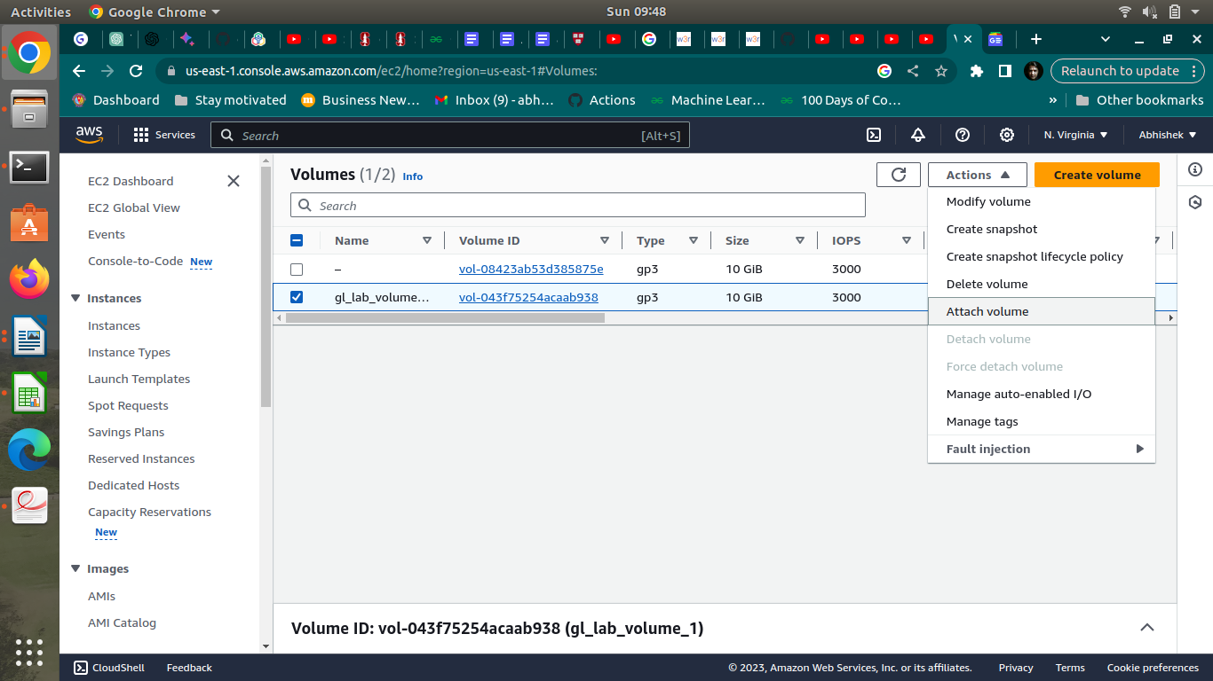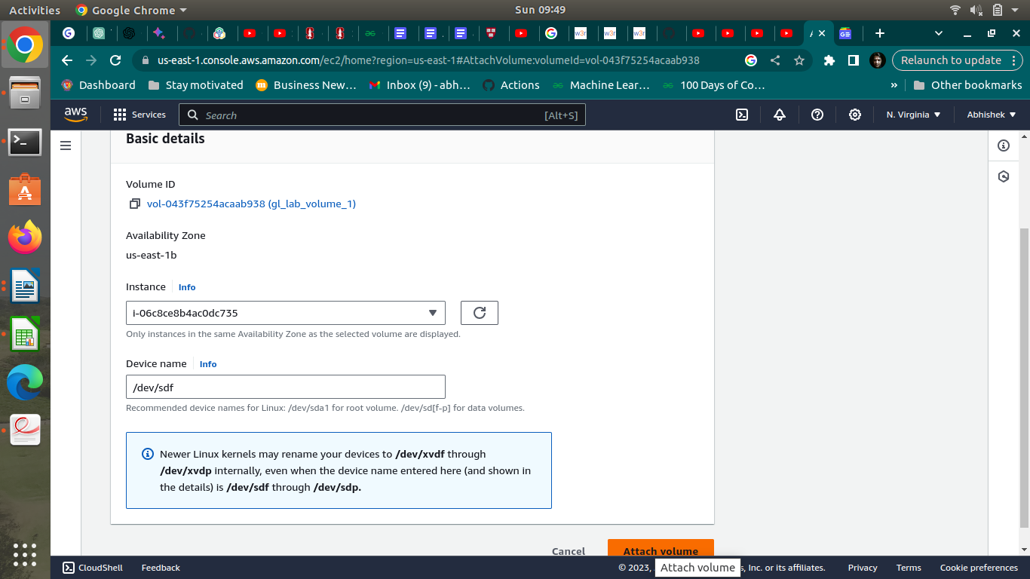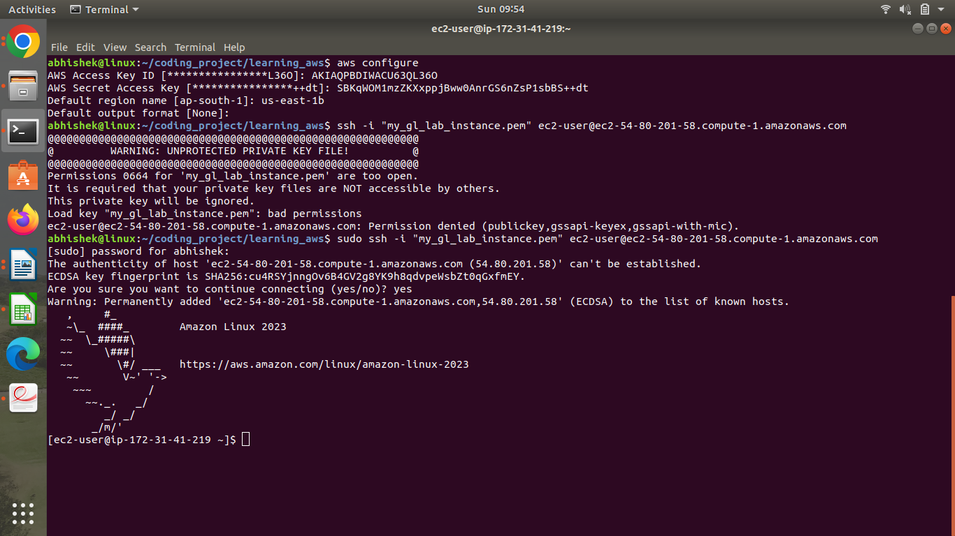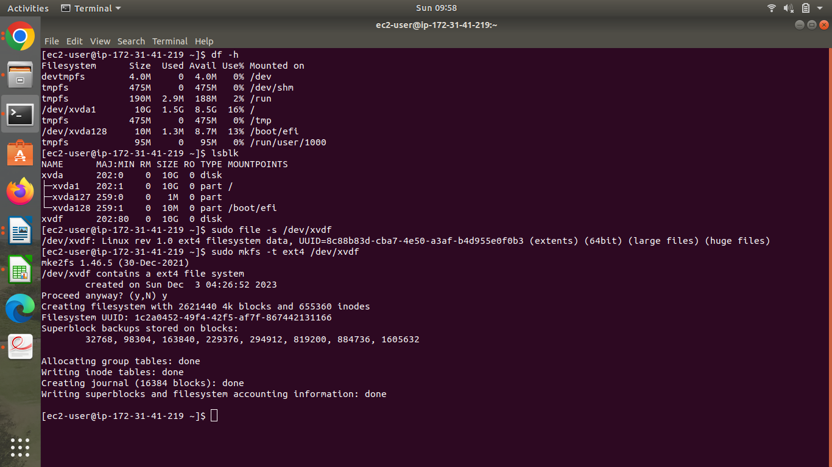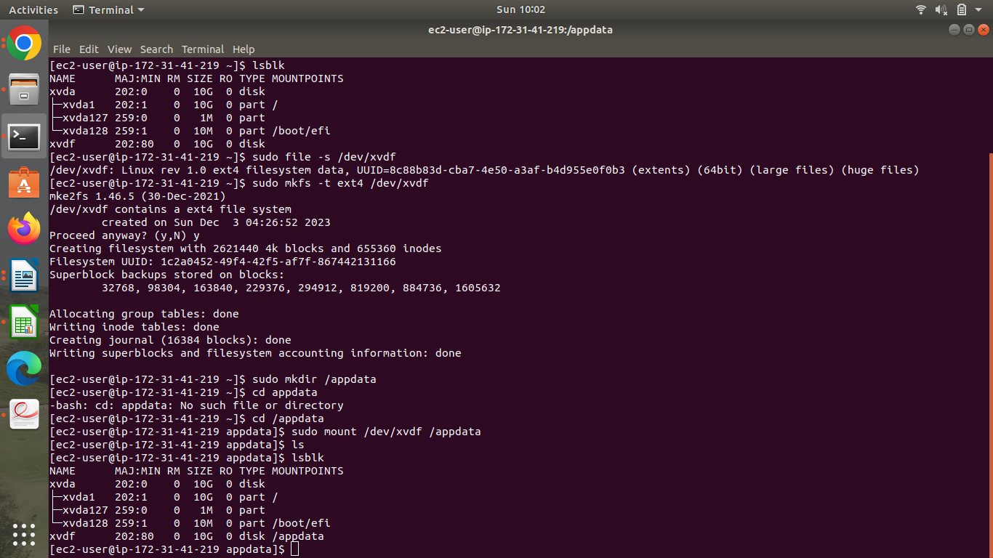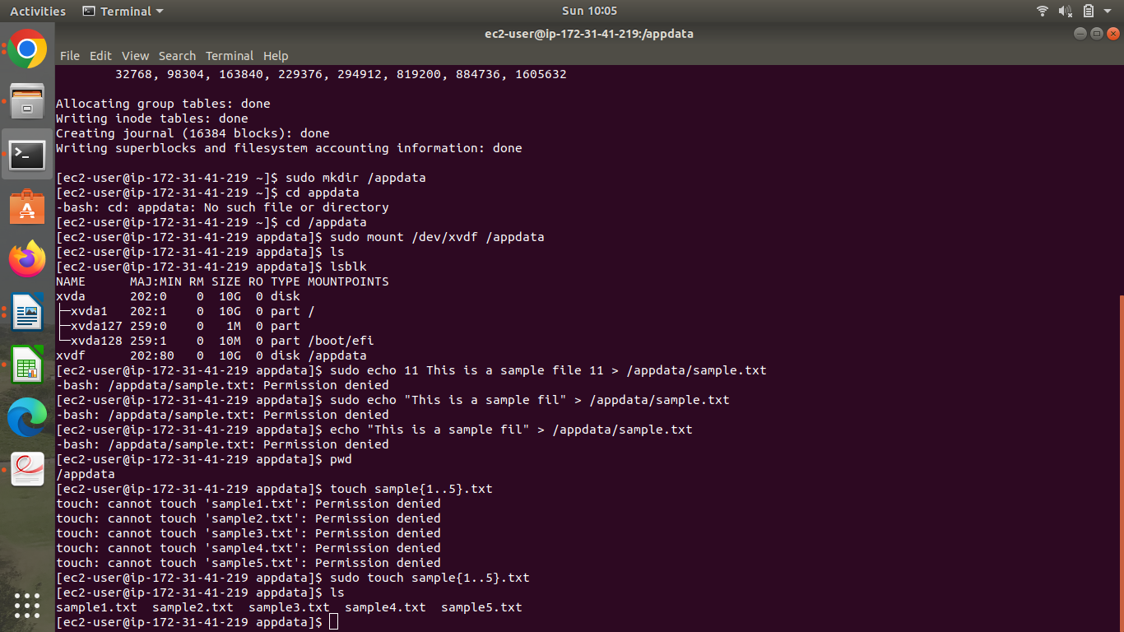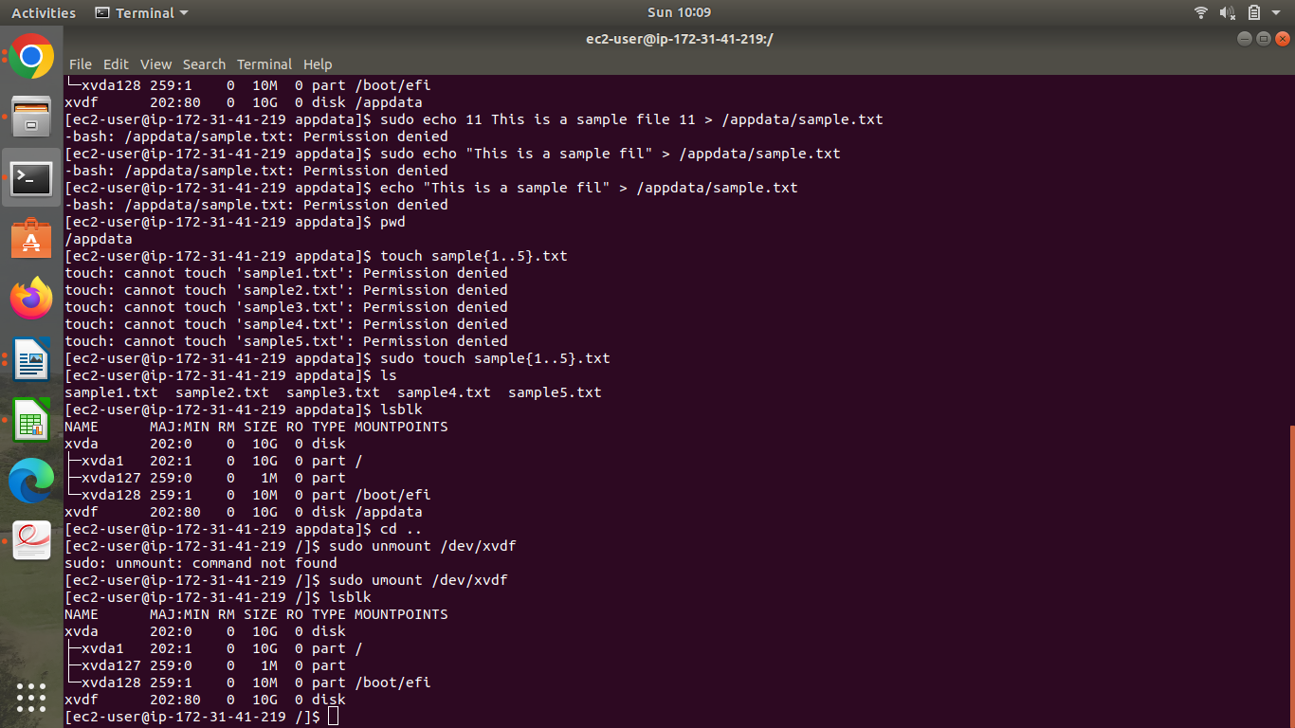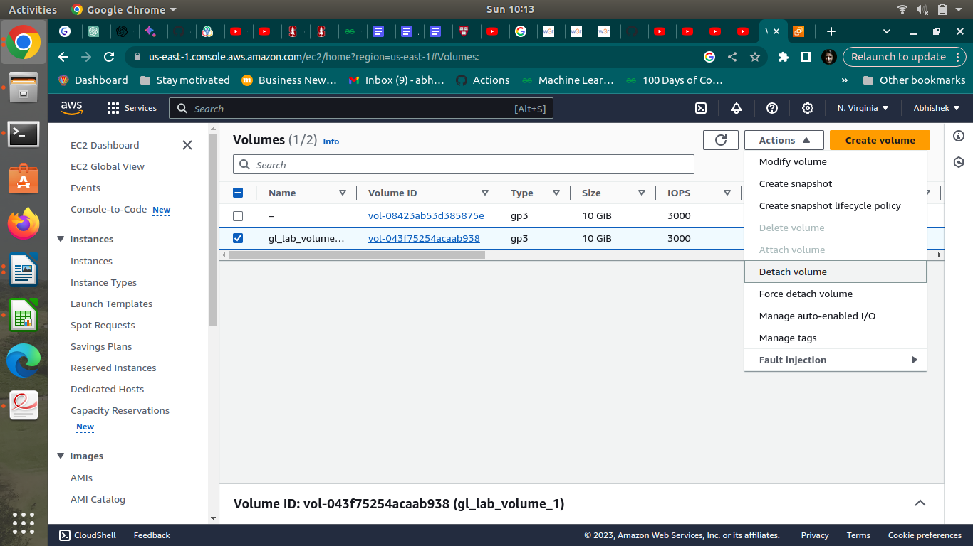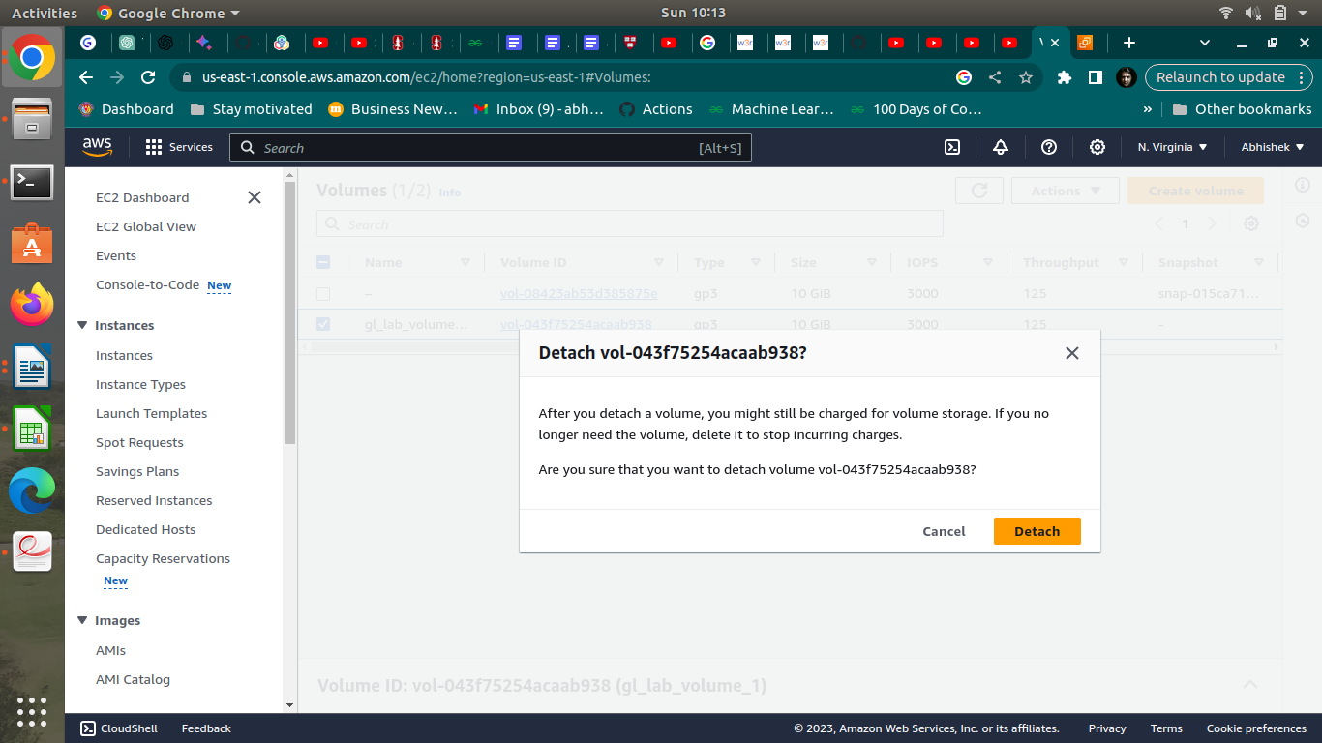

4. **Snapshot**

1. Create a snapshot of the detached Volume
2. Create a new SSD volume of 15G and apply the snapshot to it
3. Attach, mount and check if the data is there

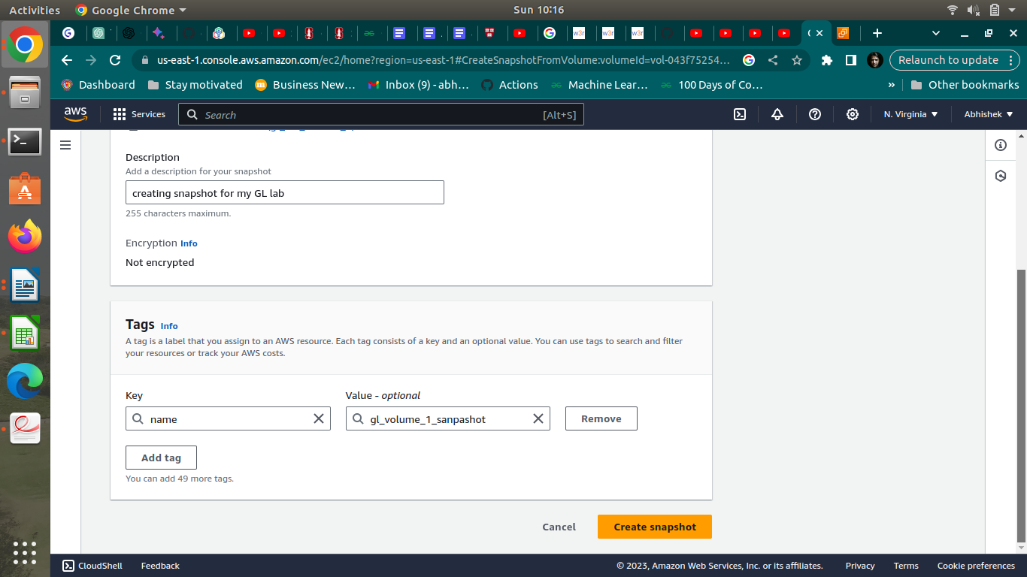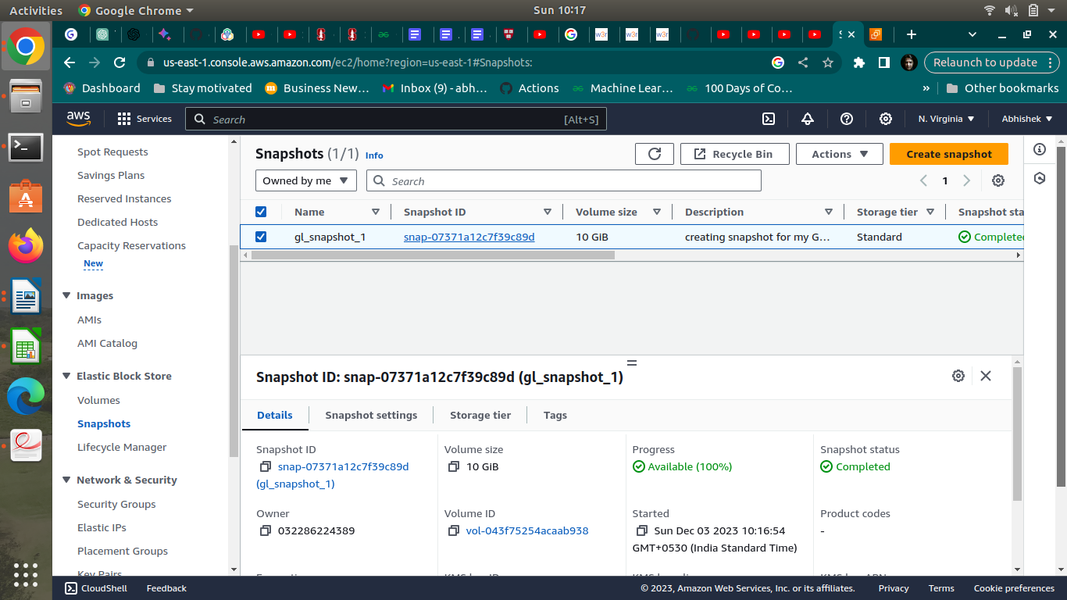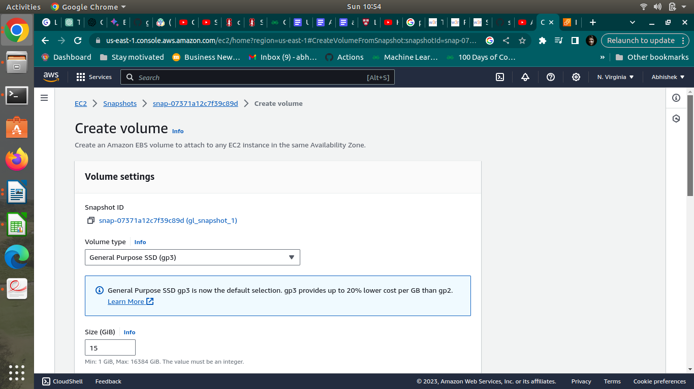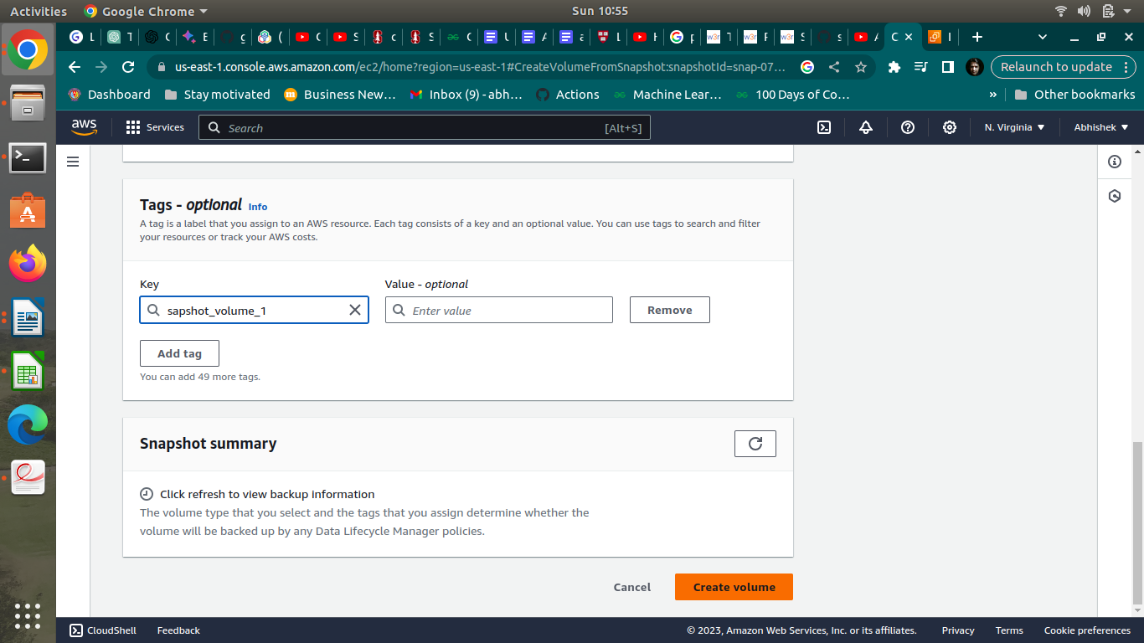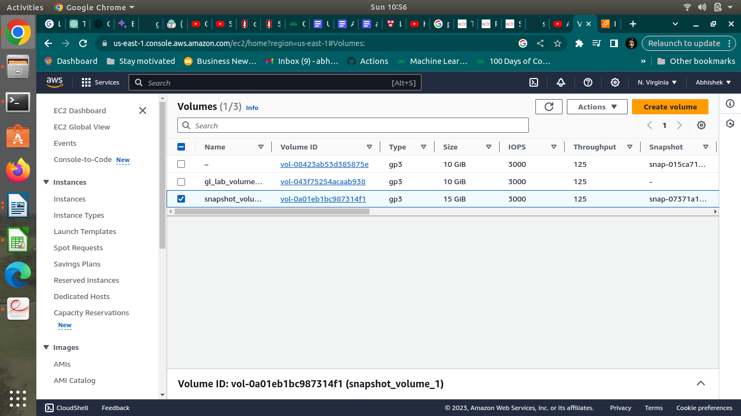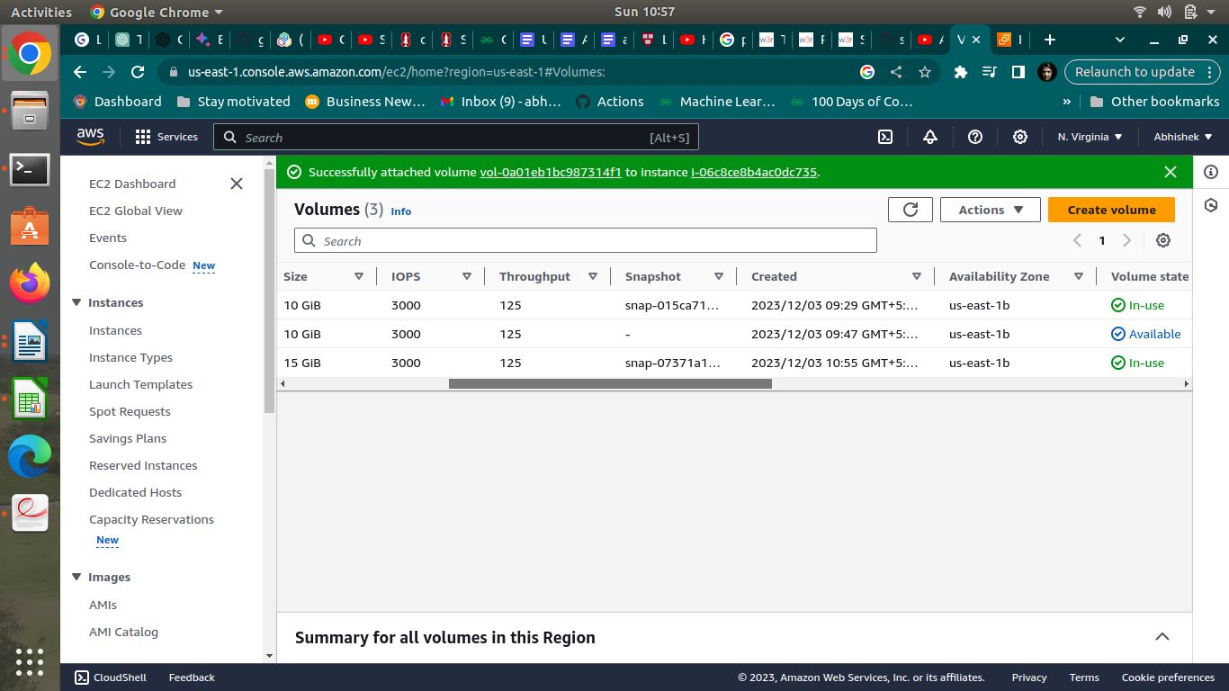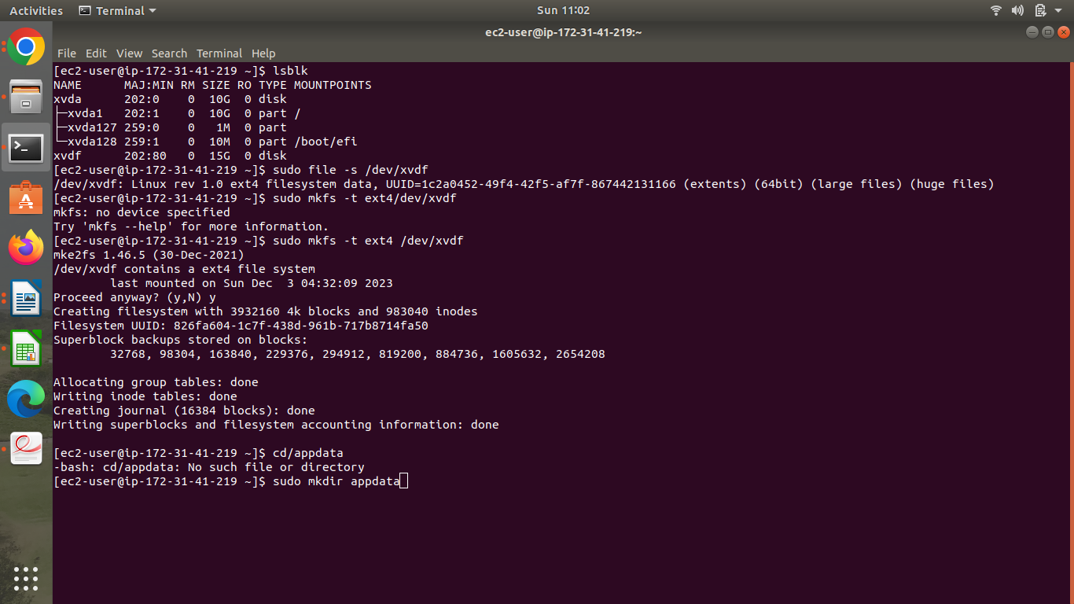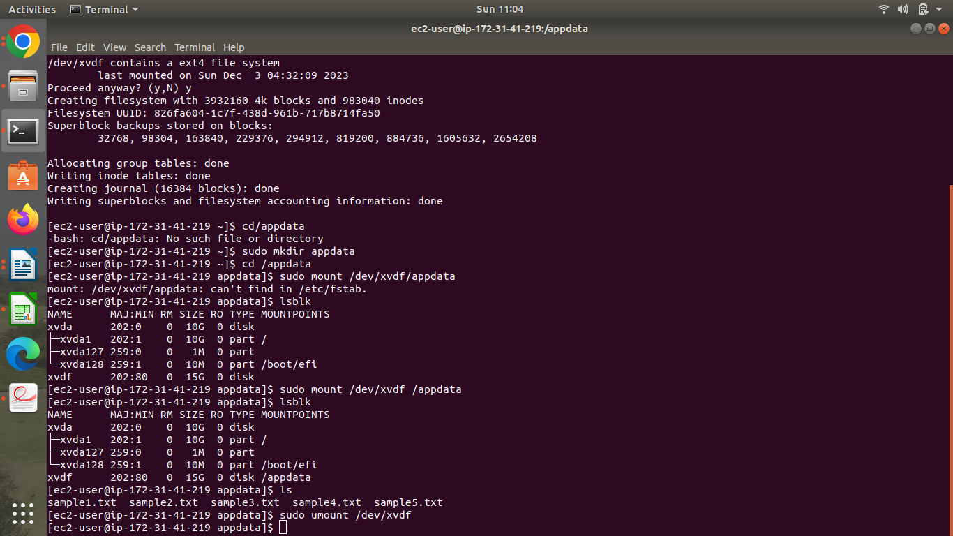

1. Use the S3 browser console to create a bucket that is unique to the region
2. Use the CLI to
3. upload a few (non-sensitive) files from your local machine to S3 bucket
4. List the buckets
5. List the contents of buckets

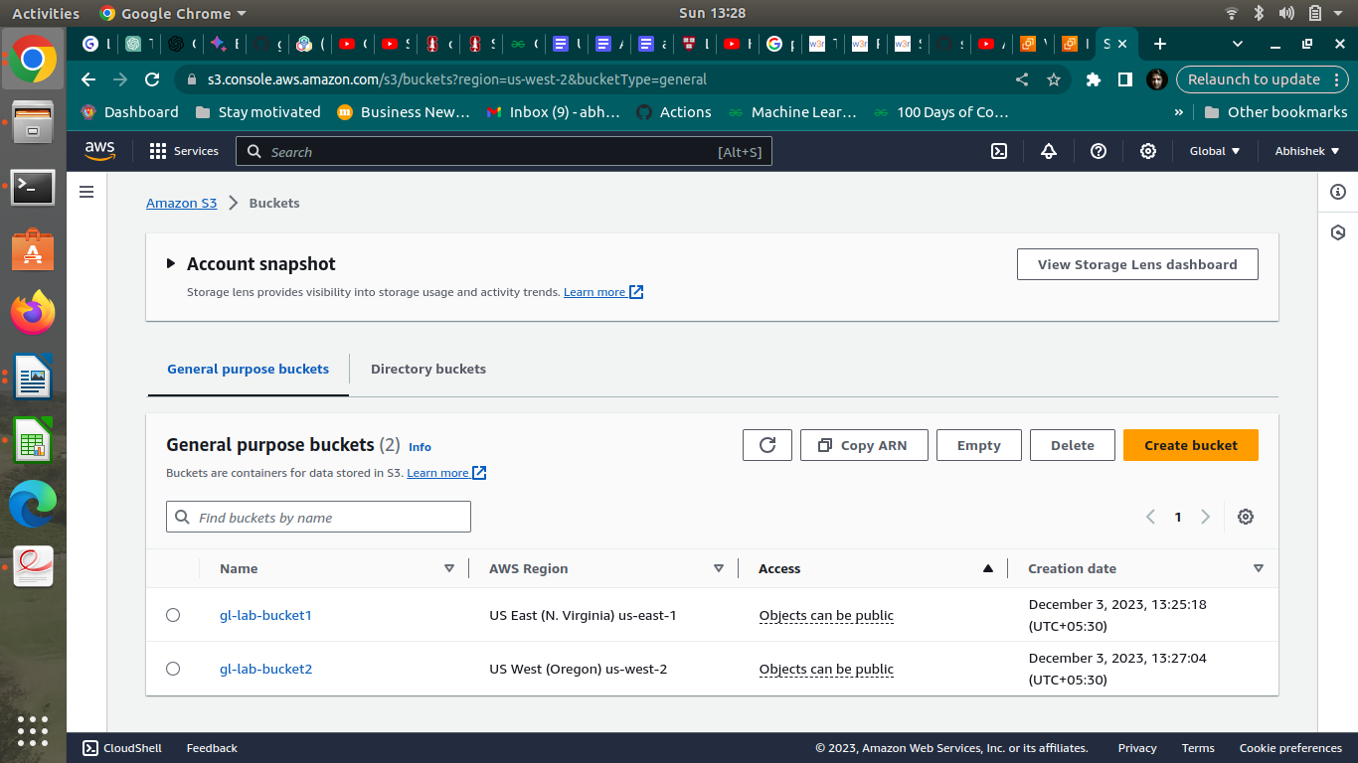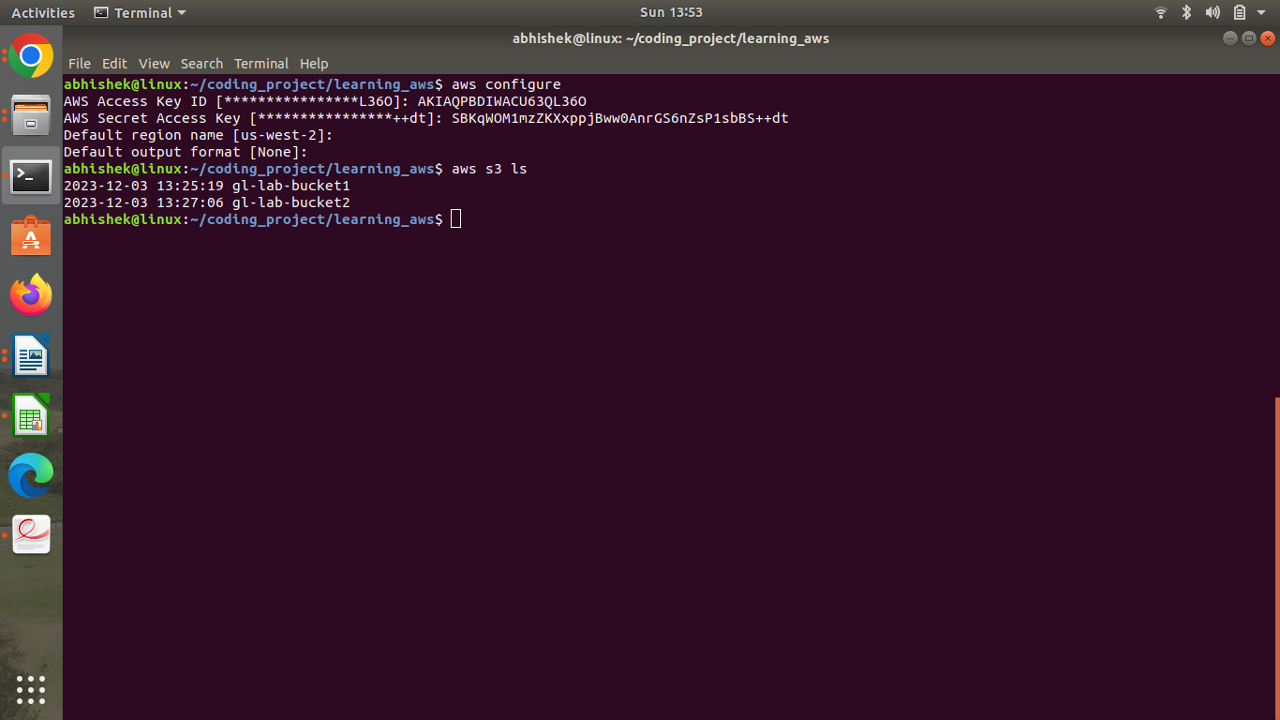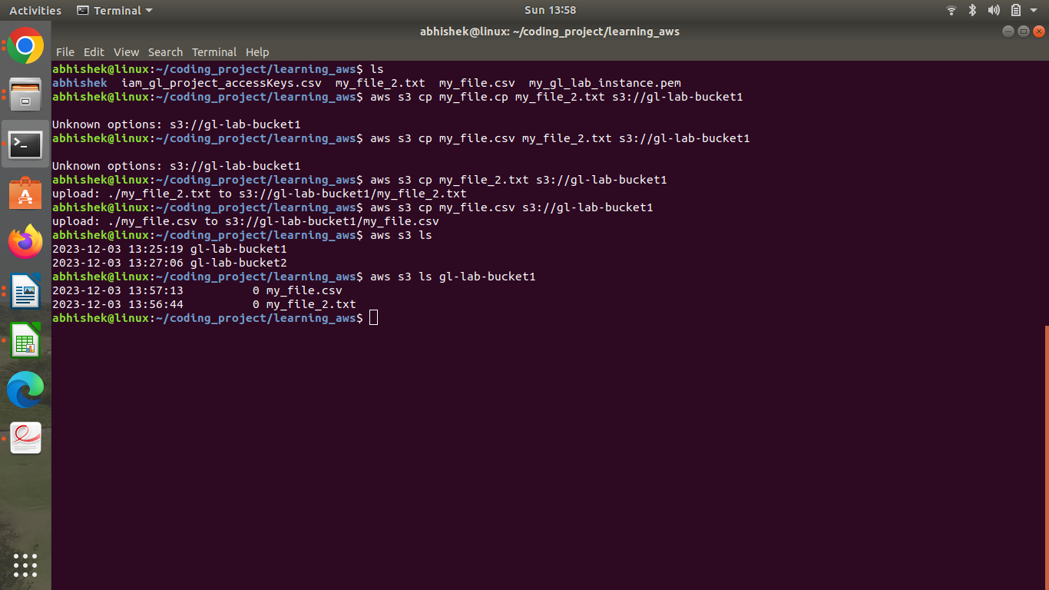

**3. Enable Versioning of the bucket**

**4. Enable cross region replication**

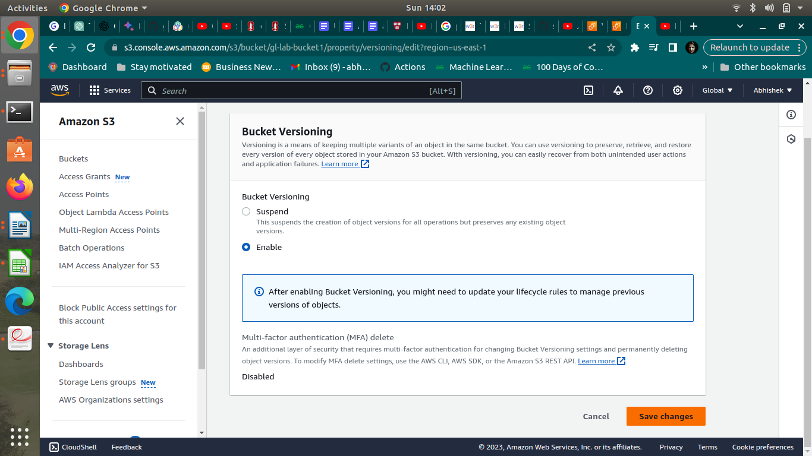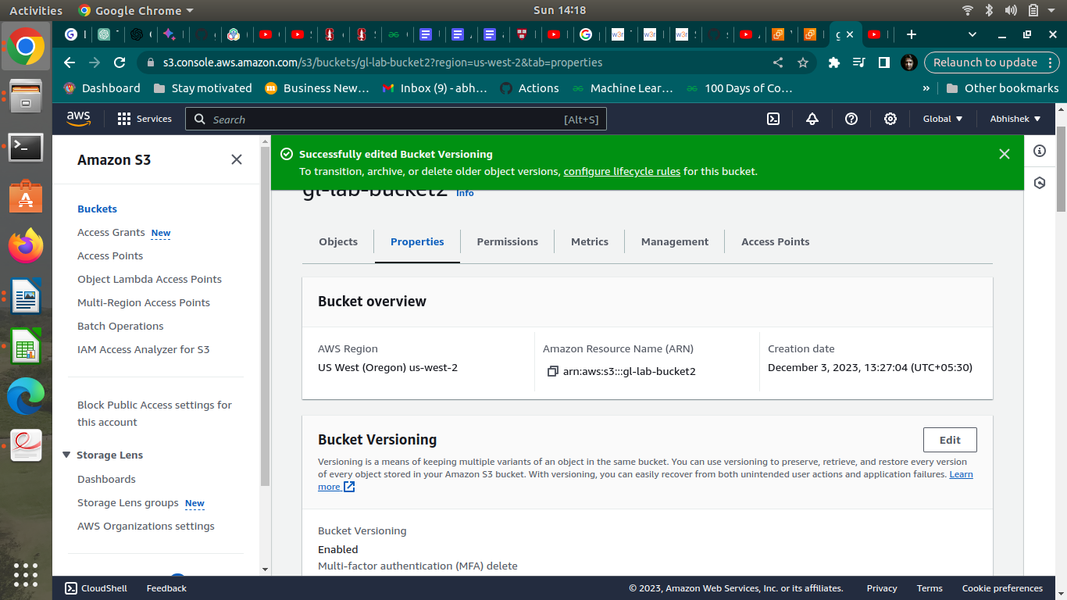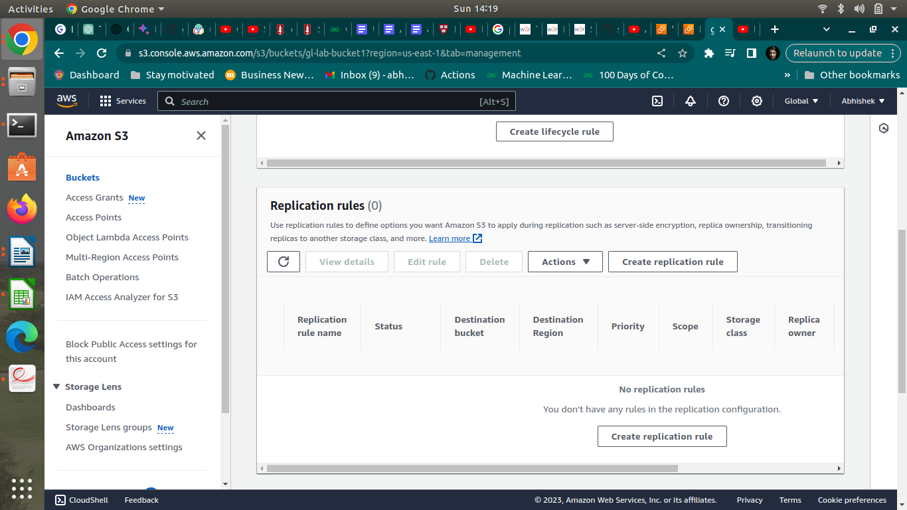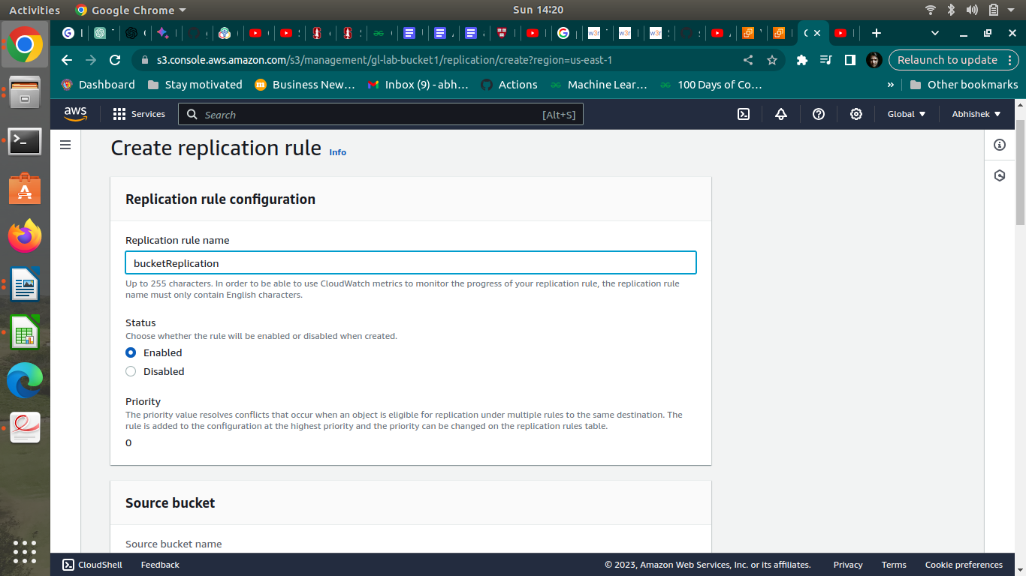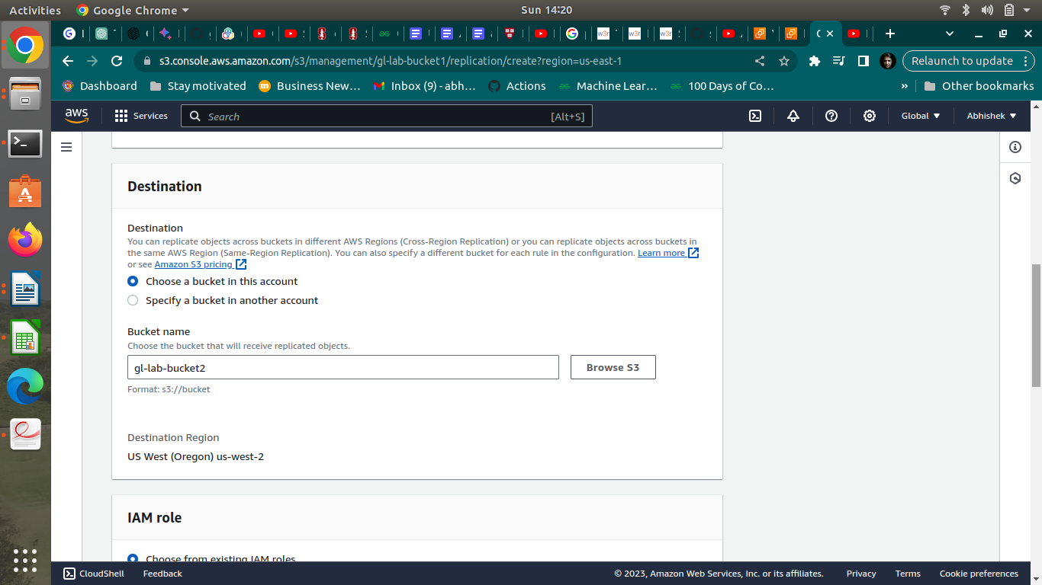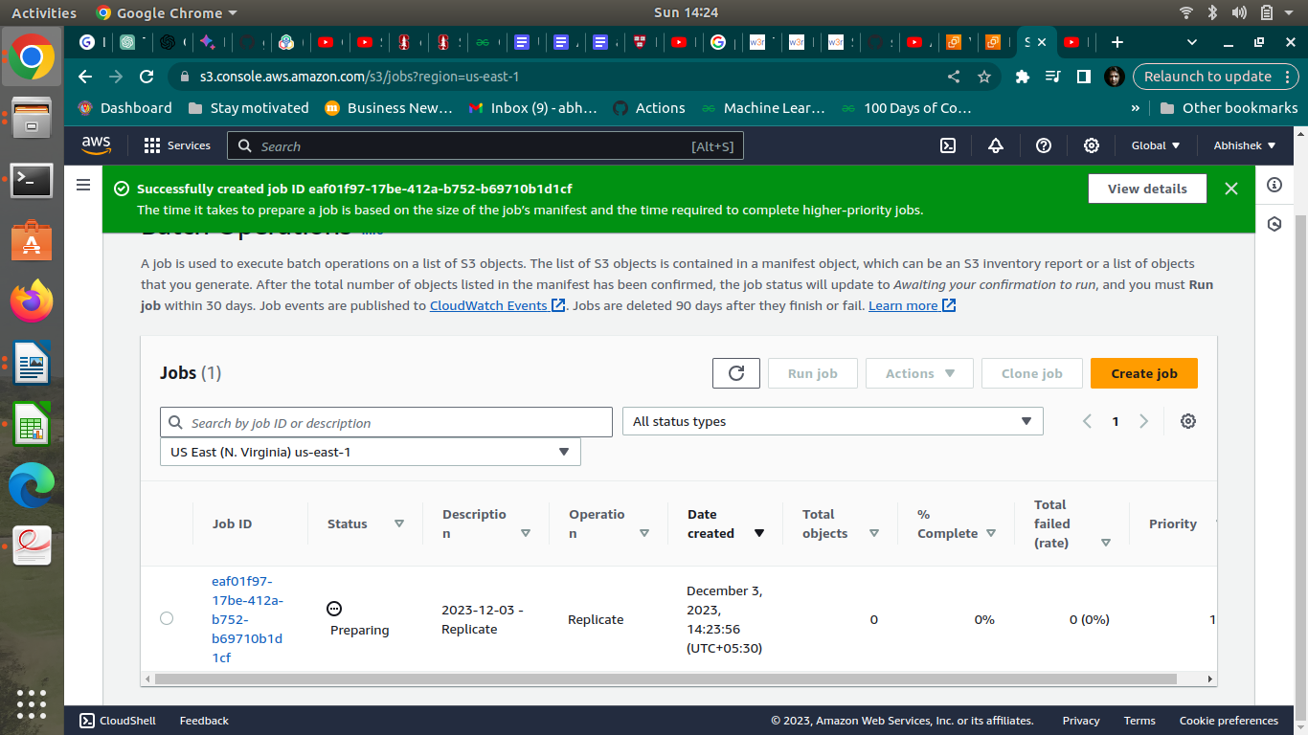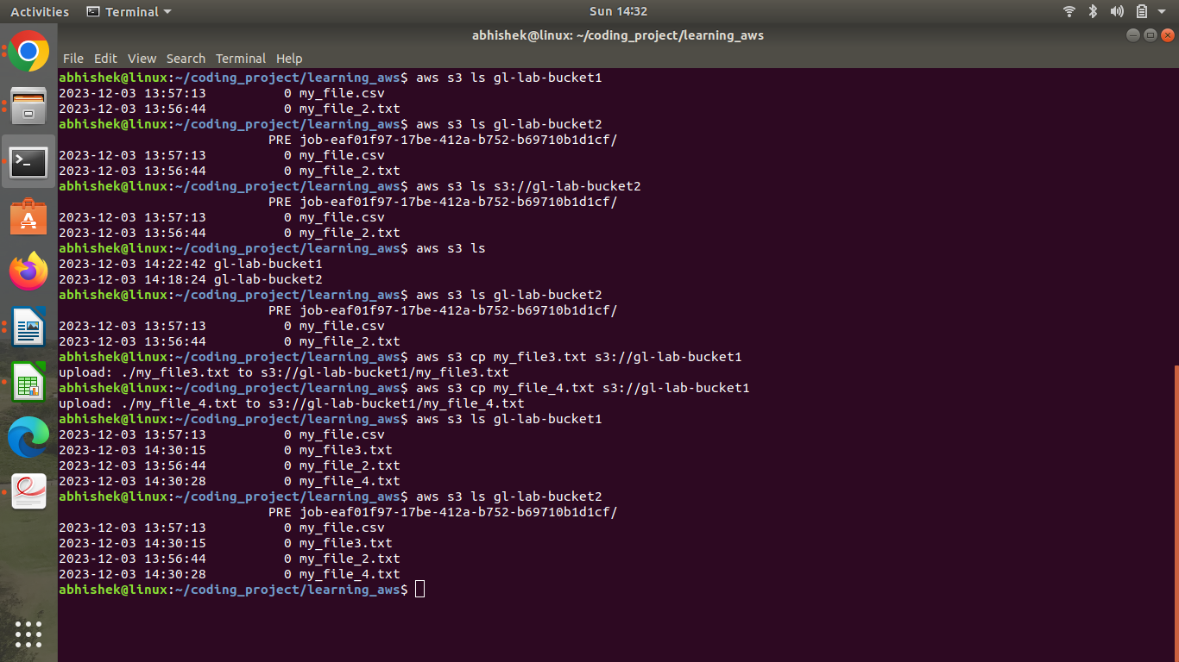

**5. Q: State your observations of the existing objects (are they replicated? )**

My Observations: When we enable cross-region replication (CRR) in AMazon S3, the existing objects in the source buckets are not automatically replicated to the destination bucket. Replication applies to new objects that are added to the source bucket after CRR is enabled.

**6. Using the CLI, upload a few new files to the same bucket.**



**7. Q: State your observation of the new objects.**

After enabling cross-region replication, any new objects added to the source buckets are automatically replicated to the destination bucket. This includes both the objects that existed before replication was enabled (if they are modified or overwritten) and any entirely new objects.